15 MIN 

COUNT YOUR POINTS !



**REMAINING ?**

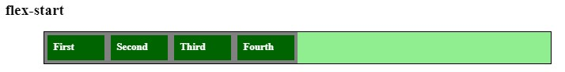

100

px

800px

# 300 500 800

**400**



**REMAINING ?**

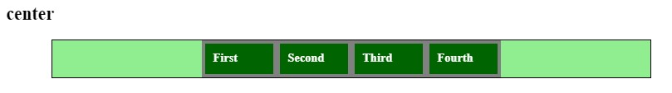

100px

800px

# 400 300 150

**200**



**REMAINING ?**

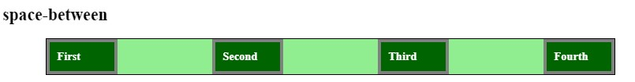

100

px

800px

## 125 200 100 133.33



**REMAINING ?**

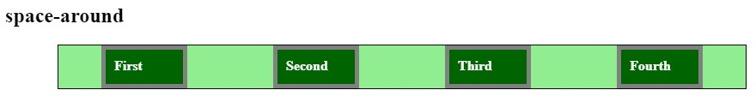

100

px

800

px

# 50 75 125

**100**



**REMAINING ?**

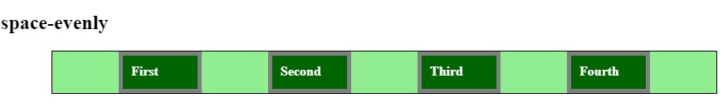

100

px

800px

## 400 / 4 500 / 4 400 / 5 800 / 5

justify-content positions Flex-items on the: **main axis cross axis ronan axis** align-items positions Flex-items on the: **main axis cross axis ronan axis**

# Which property use to change items' direction? flex-direction item-direction Ronan-direction

 Same Same or different ?

**justify-content :** space-around **justify-content :** space-evenly

|  |  |  |  |  |  |  |  |  |  |  |  |  |  |  |  |  |  |
| --- | --- | --- | --- | --- | --- | --- | --- | --- | --- | --- | --- | --- | --- | --- | --- | --- | --- |
| |  |  |  |  |  |  |  |  |  | | --- | --- | --- | --- | --- | --- | --- | --- | --- | |  |  |  |  |  |  |  |  |  | | |  |  |  |  |  |  |  | | --- | --- | --- | --- | --- | --- | --- | |  |  |  |  |  |  |  | |

FLEXBOX

**CHAPTER 3**

Flexbox items properties

# OBJECTIVES FOR TODAY

## flex container

Continue to learn properties applied to :

flex **items**

**Flex container Flex items**

# OBJECTIVES FOR TODAY

|  |  |  |  |  |  |
| --- | --- | --- | --- | --- | --- |
|  | |  |  | | --- | --- | | **Flex container** | **Flex items** | | flex-direction | **align-self** | |

justify-content

flex-grow

 align-item  **flex** flex-shrink

flex-basis

 **flex-wrap**

 **Margins** with flex

EXPLORE

# Activity 1



20 MIN INDIV

## Draw the result after applying each flex property on the container

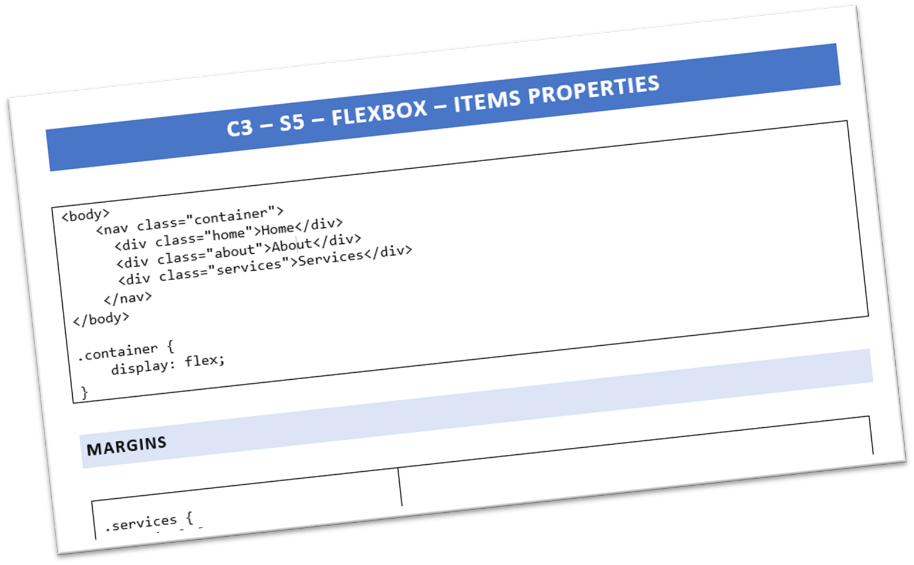

SHARE **Activity 2**

  S**TEP1** - INDIVIDUALY, CHOOSE A TOPIC TO EXPLAIN:

20 MIN

Meaning of:

•

flex

-

wrap

Meaning of:

•

flex

-

grow

Meaning of:

•

flex

-

shrink

Meaning of:

•

flex



### **STEP2** - EXPLAIN THE TOPIC TO YOUR GROUP



10

MIN



10

MIN

**STEP3** - CLASS SHARING TIME !

EXPLAIN

# Teacher Demo



10 MIN CLASS

|  |  |
| --- | --- |
| **Flex container** | **Flex items** |

**flex-wrap** flex-grow

**flex** flex-shrink

flex-basis

 **Margins** with flex

 **align-self**

10MIN 

COUNT YOUR POINTS !

|  |  |  |  |  |  |  |
| --- | --- | --- | --- | --- | --- | --- |
| HTML | |  | | CSS | |  |
|  | <div class="flex-container">  <div class=“div1">1</div>  <div class=“div2">2</div>  <div class=“div3">3</div>  <div class=“div4">4</div>  </div> | |  | | .flex-container { display: flex; }  .flex-container>div { width: 200px;  } | |
|  | |

200px



.div3 { flex-grow: 1 }

How to get this ?

**B**

**A**

remaining

200px 200px

.div3 { flex: 1 } **C** .div3 { flex-shrink: 1 } **D** .div-container { flex-shrink: 1 }

How to get this ?

200

px

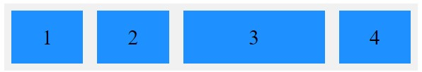

|  |  |  |  |  |  |  |
| --- | --- | --- | --- | --- | --- | --- |
| HTML | |  | | CSS | |  |
|  | <div class="flex-container">  <div class=“div1">1</div>  <div class=“div2">2</div>  <div class=“div3">3</div>  <div class=“div4">4</div>  </div> | |  | | .flex-container { display: flex; }  .flex-container>div { width: 200px;  } | |

**A** .div3 { flex-grow: 1 } **B** .div3 { flex: 0 } .div3 { flex-shrink: 0 } **D** .div-container { flex :0 }

**C**

## HOMEWORK



### INDIV

1. - **Review** all THEORY about FLEX :

<https://vegibit.com/css-flexbox-tutorial/><https://css-tricks.com/snippets/css/a-guide-to-flexbox/#aa-flexbox-properties>

1. – **Write your own handout** to summarize what you have learnt on FLEX
   * Design your handout on power point
   * 2 slides max
   * You should explain all FLEX properties you have learnt - You should be clear and creative !